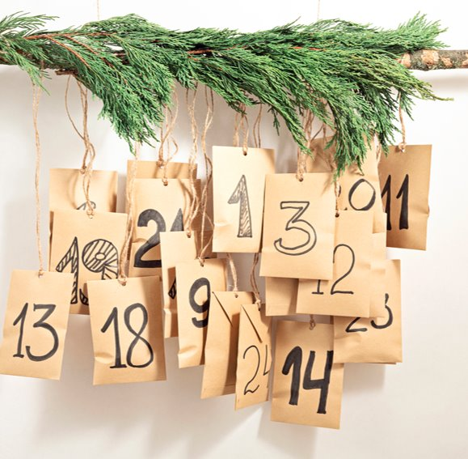

Holiday Bin Collection Check​

Residents should check their rubbish and recycling collection dates before the holidays to avoid a missed collection
Check your bin collection day | North Yorkshire Council
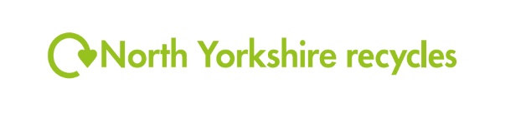

Household Waste Recycling Centre's​
Household waste recycling centres | North Yorkshire Council

Open daily except Wednesday​s. Closed on 25 -26 December 2025 and 1 January​ 2026

